CHAPTER I

**INTRODUCTION**

**Project Context**

Transportation is one of the most important aspects of a day-to-day activity. Transport and communication are considered the cornerstones of many human civilizations because of their importance in linking neighboring barangays and towns to each other. Without transportation there is no interconnection and communication between people. In Bato, Leyte the tricycle driver is using android phones or smart phones. There registered tricycle is 212 and they have policy which is the unregistered tricycle are given 1 month to comply for their franchise.

During this time of pandemic, the transportation in the town become limited and the commuters are having trouble when they want to go to other barangays or going into town because of the limited running tricycles. Having the implementation of the COVID-19 health protocol in the transportation, the tricycle can only accommodate 3 people in their trikes. Which has a big impact in their means of living and daily income. They can have a minimum of P300 to a maximum of P400 pesos daily income which is too low during this time of crisis unlike before the pandemic (Municipality of Bato, Mayor Nathaniel B. Gertos, Section 5. Tricycle Operators)

**Purpose and Description of the Project**

In this study, a system is designed for the booking of tri-ride trips using GPS technology for navigation and location finding to incorporate the Global Positioning System (GPS). As the system runs on client server technology, it will work in any android device. Most people have their own mobile phones, so they can take advantage of the design technology even in remote areas. Using the mobile phone, tri-ride can be used to book directly with the trike operators through network. The system will address the tricycle in Bato, Leyte. With GPS technology, the trike operator can easily locate the location of commuters and can directly access direction via the trike driver’s phone. To facilitate the booking, the phone of the driver and commuters will be interconnected by a major system. Tri-ride system has a database in which all transaction is documented, and this database could be used to record the details of the driver like name, address, license number, phone number, operator of the driver, etc. The major contribution of this application it was design for tricycles and can often be used in remote areas. The system is web-based so all the transactions can be recorded, and data can be retrieved from the web using an internet connection. Commuters in Bato, Leyte will benefit from this because it will fix the commuters problems in taking a tricycle. Moreover, the central system which will be installed in the server can collect a series of comprehensive information since the design is suitable to handle data.

**Objective of the Project**

The main objective of this study is to design and develop a Web-based application that would act between tricycle driver and passengers in improving the ride hailing experience. Specifically, it aims:

1. Integrate GPS Technology for mapping and location finding in which data will be collected.
2. Design a web-based online booking system that will communicate and interconnect the passengers, drivers, and owners to generate useful information and records as inputs to produce data analytics.
3. To evaluate the website to tricycle drivers and different stakeholders
4. Create a module for Admin, Client, and Driver

**Scope and Limitations of the Project**

The project will be a web-based application that will primarily be tested using android-based operating system for mobile phones for the booking and communications of both tricycle drivers and commuters. The data that will be collected will exclusively be used for booking or hailing of tricycles. The project will be limited to having the users for both sides of the project to have smartphones; Tricycle driver must have a Smartphone and likewise for the passenger. Other features and requirements aside from the features specified are not part of the system. Cost benefits and infrastructure analysis are not covered by this study. Furthermore, the operation of the developed system is exclusively for tricycle commuters and drivers of Bato, Leyte.

CHAPTER II

**REVIEW OF RELATED LITERATURE**

**Related Literature/Theoretical Background**

Leadership Theories: Managing Practices and Challenges by Hawkins, Cheryl study the different three leaders in leadership theories. Community College Enterprise 2009, Volume 15 (p.39-62). Servant leadership is the leader focuses on the needs of their employees, and business leader focus on outcomes and quality methodologies. Finally, transformation leaders structure all employees work toward the mission, establish open communication system within the institution and then focuses their work on strengthening and sustaining their institution for the future. A person designed for carrying a power is not enough due to retirements is predicted by leadership theories. In relation to this, as a tricycle driver that have association call Tricycle Operators and Drivers Association (TODA). In the said association, drivers have founder or the one that stands as a leader. The leader that handles the tricycle drivers or operate them. Focusing on the member is the main objective of the said leader. If not, tricycle drivers will not be disciplined the way drivers get passengers.

In the other hand, the study of (Molz&Gunter,2010) states that the theory of Behavioral Decision Making and Suggestion Process discussed about the common features between the domains of behavioral decision making and suggestion processes are traditionally considered to cause not good enough human behavior. Second, two common related issue are discussed (1) utility functions in behavioral decision making and (2) avoidance of something that does not have clear meaning, in connection of this theory in the study, drivers’ decisions may be associated with strategic choices, such as route selection, or tactical decisions, such as driving at a certain speed or alternating driving style. If a driver is undecided about whether to stop and slowdown or to proceed, they could increase the risk of collision due to either incorrect use of signals, inappropriate speed, sudden braking without checking review mirrors or impulsively increasing speed. All these actions can directly result in a collision, especially as the other drivers may not be able to anticipate the undecided driver’s action and react in time. Drivers need to be always alert, focus to drive to prevent accident.

**Related Studies**

Based on the study of Huerta (2015), tricycles are the second most popular means of transportation here in the Philippines. On the statics from year 2013, the number of registered Tricycle in the Philippines is 3.58 million. These vehicles have been around for quite some time that banning them is impossible. Tricycle or sometimes called as “trike” is a three-wheeled public utility vehicle consisting of a motorcycle and an attached passenger’s side car. These tricycles can be found everywhere in the country except on major or main roads.

According to Rahman (2013), most vast urban communities around the globe are experiencing fast transport segment improvement to provide development for expanding urbanization. Along these lines the issue of portability, access equity, congestion, operational security or move all ecological manageability are ending up progressively urgent in transport planning and arrangement making. The mainstream reaction intending to these issues has been demand the executives, through enhancement of mechanized public transport (MPT) modes (transport, train, cable car) and non-mechanized public transport (NMT) modes (walk, bike); enhanced fuel innovation.

Moreover, kojima (2011) state that two-stroke motor, two-and three-wheelers involve aver half of the all-out vehicle populace in South Asia and, in that capacity, are probably going to be huge contributor of particulate air contamination in vast urban communities. Since there is no contributor for particulate source from two-stroke motor gas vehicles, there is little information accessible measuring their outflow levels.

According to the Secretariat of the East African Community (EAC) (2020) report, passenger transport has decreased by approximately 50% as countries within the region use various restrictions to prevent citizens’ movement. Truck drivers have never been more visible, highlighting their position as critical employees in difficult times like these. Africa depends heavily on the freight transport industry to keep supply chains running. With a substantial decline in the number of international and regional freight flights able to operate, it is increasingly relying on road transport operators. They implemented restrictions on the number of people in drivers’ cabins, and in Uganda, truck drivers are not allowed in hotels and guest houses along their routes. Instead, they need to always stay in their places.

According to (Romeo 2015) tricycle is a three-wheeled vehicle, it is said to be more accident-prone compared to four-wheeled vehicles, this is also the reason why senior administration law maker in the Philippines are proposing safety and professional training for drivers and operators of tricycle.

According to (Sietchiping, Permezel and Ngomsi 2012) a good transportation mixes generally exist, that is, the presence of none, motorize and private motor vehicles and a good range public transportation system notably basis in different sizes as well as choices in trains and monorails. On the other hand, especially with that of public transportation, the opposite same to be happening in most cities in developing countries.

According to (Olvera et all. 2015), said that the commercial use of tricycle is facilitated by the combination of three factors; the shortage of transport supply, which includes the lack of means of transport (private vehicles and public transport) and the quantitative and qualitative deficiencies of the road network; the availability and low cost of operations.

According to (Paolo, 2015), tricycle drivers need to meet one group condition and ensuring multiple documents before commencing which brought passengers. In general, they need to showcase some Land Transportation Office (LTO) registration, a barangay clearance for their place operation and payments of registration fees. Tricycle driver must be bona fide residence and must hold accident insurance. It also needs tricycle to carry trust and rig silencer in their exhaust pipes. Tricycle drivers are the only ones who are permitted to operate within boundary. The boarders are divided according to different Tricycle Operators and Drivers Associations (TODA) at a local government unit (LGU). TODA consist of the following tricycle, driving sector tricycle driver need to get TODA permission before the trip within the boundary. The trays are the same TODA also has the same colors.

CHAPTER III

**TECHNICAL BACKGROUND**

**Technicality of the Project**

The proponent had gathered all related research about the research and had brainstormed about what technologies will be used. As the project is still ongoing, the proponents will still search for tools and software that can help improve the development of the project.

Tri-Ride: A Web Based Tricycle Booking System with GPS and Navigation is a web-based system where the tricycle driver able to log in and get notification for service request and likewise the passenger can book or hail for a ride. These are the technologies to be used by the proponent of the project, jQuery, PHP, GPS and MySQL. Technologies being state above are also the technology being use by the proponent in the project.

**Details of the Technologies to be used**

There are many technologies that is used by the proponents to the project. Some of them are listed below:

* CSS – use to style HTML markup code.
* HTML – is the main section where the content is stored and displayed.
* Laravel 9 – is a PHP Framework and the framework to be used for the project.
* PHP – is the Programming Language that will be used for this project.
* MySQL – use to store/save data.
* jQuery – use to function calls and supports object-oriented elements.
* Leaflet – used to digitized map.
* Mapbox – used for finding and processing location points for routing.

The proponent will be using Web Server which is use HTTP and other protocol to respond to Client request made over World Wide Web. The features of this server will also be used by the proponents to develop and improved the proposed Tri-Ride: A Web Based Tricycle Booking System with GPS and Navigation.

**How the Project will work**

The diagram below shows the Conceptual Framework of the project; this shows mainly shows that the system will have two sides which is the Commuter Side and the side for Drivers, the system will be able to accept, validate and store requests and/or transactions made and sent from both sides.

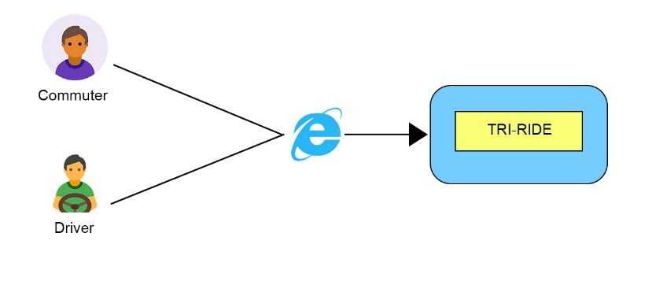

Figure 1. Project Conceptual Framework

The diagram below reflects the Architectural Layout of the project. The commuter will be able to Login/Sign Up once the application is accessed online. Also, the commuter will be able to Book for Ride or hail for tricycle. The commuter can also view his/her information and Lastly the Transaction Details or Status. On the other hand, once the driver has accessed the system online; the driver will be able to Login/Sign Up in the system, see the driver’s information and the commuter location. The driver can also, view the commuter travel details such as current location, destination, and number of passenger and lastly the total payable amount or the fare.

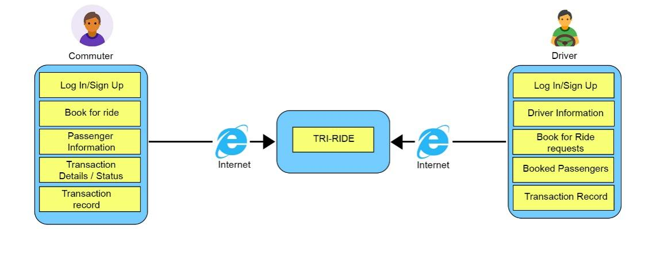

Figure 2. Project Architectural Layout

CHAPTER IV

**METHODOLOGY**

**Environment**

***Locale***

The project was conducted in Bato, Leyte and will be tested in the stated town. Bato is in Leyte, Region 8, Philippines. It is 90 miles south of Tacloban City, the regional center of Eastern Visayas.

***Population of the Study***

The population of the study will mainly be the populace of Bato, Leyte for both sides of the system, which is for Commuters, and for Drivers. The populace of Bato, Leyte will serve as the project dataset and the respondents of the study. Which will also be the bases of the systems testing and maintenance.

***Organizational Chart/Profile***

The project is a web-based form of application which will be used by the populace of Bato, Leyte. The nature of the project will not solely serve any organization, governing body or any in between. The project will be accessed by commuters and drivers that resides within the parts of Bato, Leyte in which the system will be tested and implemented.

**Requirement Specification**

***Operational Feasibility***

*Fishbone Diagram*

The diagram below is the project’s Fishbone diagram, it reflects the factors that cause the low number of available Tricycle in Bato, Leyte. The stated factors that caused the issue that the study will address. It shows that the factors that caused the issue are namely the pandemic and lifestyle of the populace of Bato, Leyte. These have led to the low number of available Tricycle on Bato, Leyte.

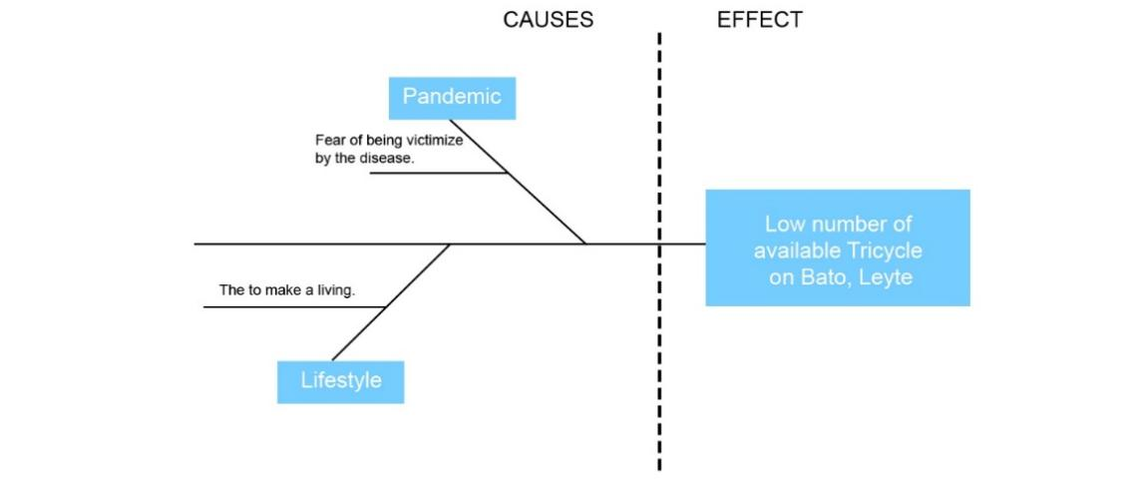

Figure 3. Fishbone Diagram

*Functional and Decomposition Diagram*

The diagram below is the Functional Decomposition Diagram of the project. It shows the functionalities and capabilities that both side of the system can make. It shows the distinct functionalities for each side of the project and shows how relevant each side of the project is to one another. The commuter side of the project has several features or stages, namely, Login/Sign Up, Hail for Tricycle, view his/her Passenger Information, view Transaction Details/Status. On the other hand, the Driver Side of the project also has several stages/functions, and this are the following: Login/Sign Up, view his/her Driver Information, Commuter Location.

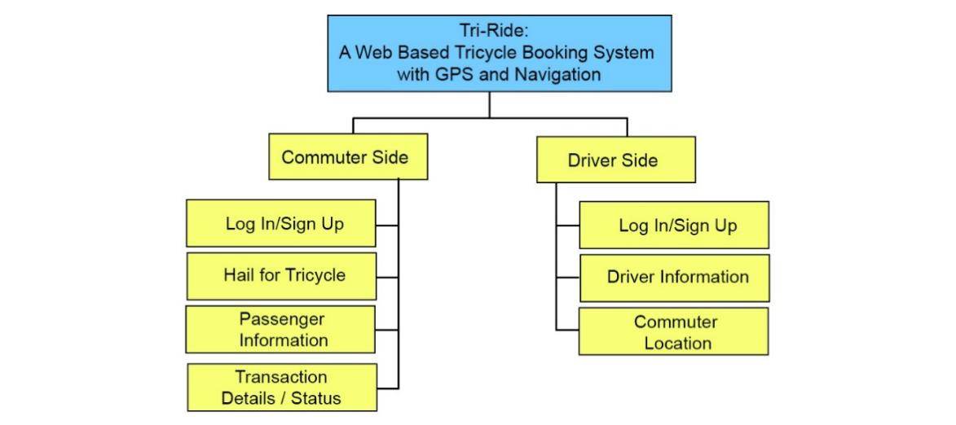

Figure 4. Functional Decomposition Diagram

***Technical Feasibility***

*Compatibility Checking (Hardware/Software)*

The Tri-Ride can be accessible in devices that has any of the following internet browsers Google, Opera Mini, Mozilla Firefox, Microsoft Edge. Also, the project can function smartphones that are android-based operating system and is connected to the World Wide Web.

*Relevance of the Technologies*

The technologies that are part in making the project are essential for this project to have a success development and implementation. Testing the project in various platforms would pave and show the effectivity of the project. This means to say, that the project should be able to function and be accessible over to the internet. In addition, the project should be able to function in devices specially in smartphones.

***Schedule Feasibility***

*Gantt Chart*

The dates on which the researchers completed their assignment are listed in the chart below. The graph shows what happened and when it happened. Furthermore, it shows the dates by which each task must be completed.

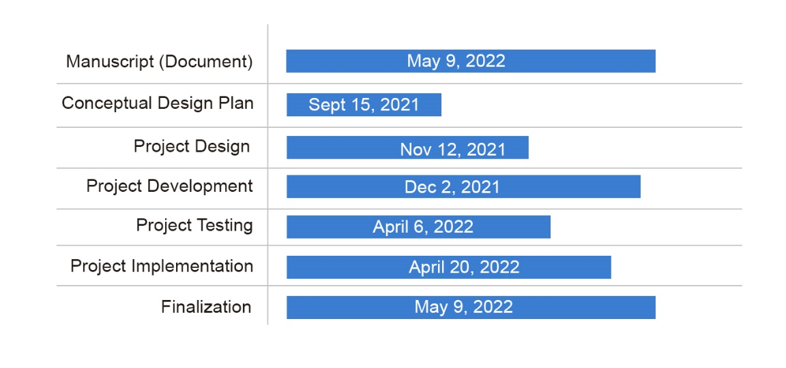

***Economic Feasibility***

*Cost and Benefit Analysis*

The table below is the Cost and Benefit Analysis of the project these are the generalize expenses of the proponents in making the project. It shows that amongst the expenses the Internet expenses has accumulated more over the other expenses and is followed Transportation and Miscellaneous which garnered 1,000.00 pesos for each. And lastly, in finalizing the project, the proponents have spent 500.00 pesos for Paper & Photocopy Expenses.

Table 1. Cost and Benefit Analysis

|  |  |
| --- | --- |
| Expenses | Amount |
| Internet Expenses | 1,500.00 |
| Paper & Photocopy Expenses | 500.00 |
| Transportation | 1,000.00 |
| Miscellaneous | 1,000.00 |
| Total | 4,000.00 |

*Cost and Recovery Scheme*

The table below is the Cost and Recovery Scheme of the project. This reflects the division of expenses for each month during the duration of the project. This shows that the overall expenses grow increasingly for each month because the project requires more expenses for the project to be accomplished.

Table 2. Cost and Recovery Scheme

|  |  |  |  |  |  |
| --- | --- | --- | --- | --- | --- |
| Expenses | Nov | Dec | Jan | Feb | March |
| Internet Expenses | 300.00 | 300.00 | 300.00 | 300.00 | 300.00 |
| Paper & Photocopy Expenses | 0 | 0 | 0 | 0 | 500.00 |
| Transportation | 200.00 | 200.00 | 200.00 | 200.00 | 200.00 |
| Miscellaneous | 200.00 | 200.00 | 200.00 | 200.00 | 200.00 |
| Total | 700.00 | 700.00 | 700.00 | 700.00 | 1000.00 |

***Requirements Modeling***

The following figure shows the Requirements Modelling for each side of the project. The commuter’s side for the driver’s side. It shows the inputs, process, control, generated outputs, and performances that each side is capacitated to implement.

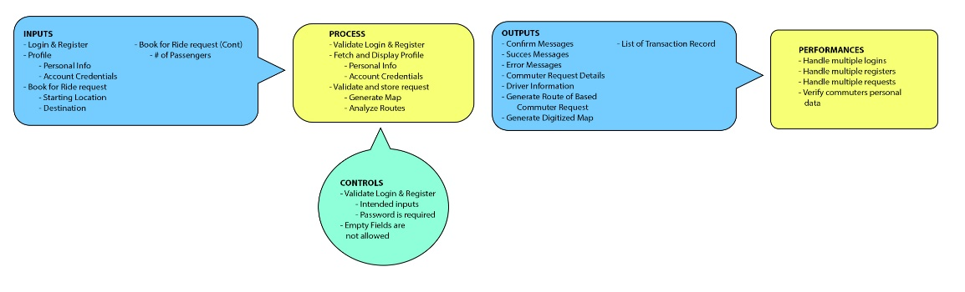

Figure 5. Requirements Modelling for Commuters Side

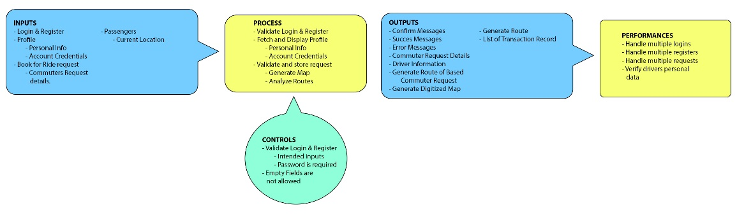

Figure 6. Requirements Modelling for Drivers Side

***Data Process Modelling***

*Context Diagram*

The diagram below shows the context diagram of the project it shows what are the essential reports, capabilities and/or features for both commuters’ side of project and for the driver’s side of the project.

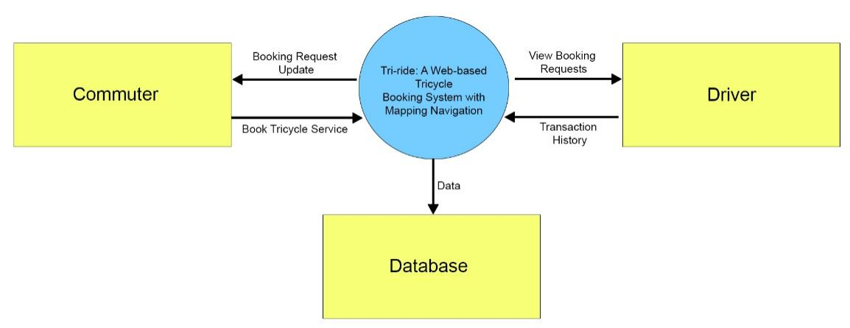

Figure 7. Context Diagram

*Data Flow Diagram*

The data flow for either side of the project is depicted in the figures below. Each figure demonstrates how data flows for the project commuters’ side. Also, how data flows for the project's drivers’ side. Furthermore, the illustrations depict the general reports that each project component generates and shows.

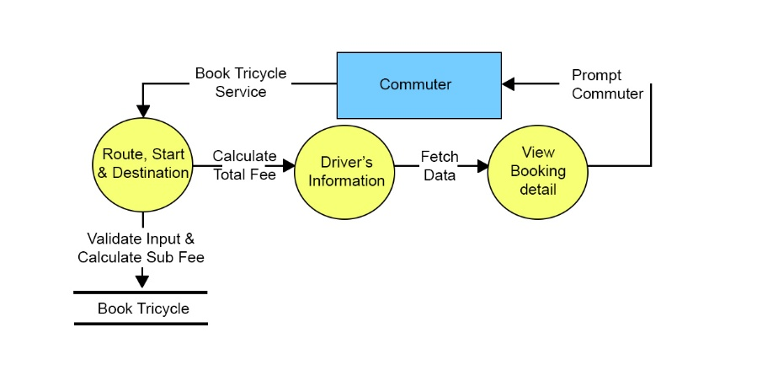

Figure 8. Data Flow Diagram for Commuters’ Side

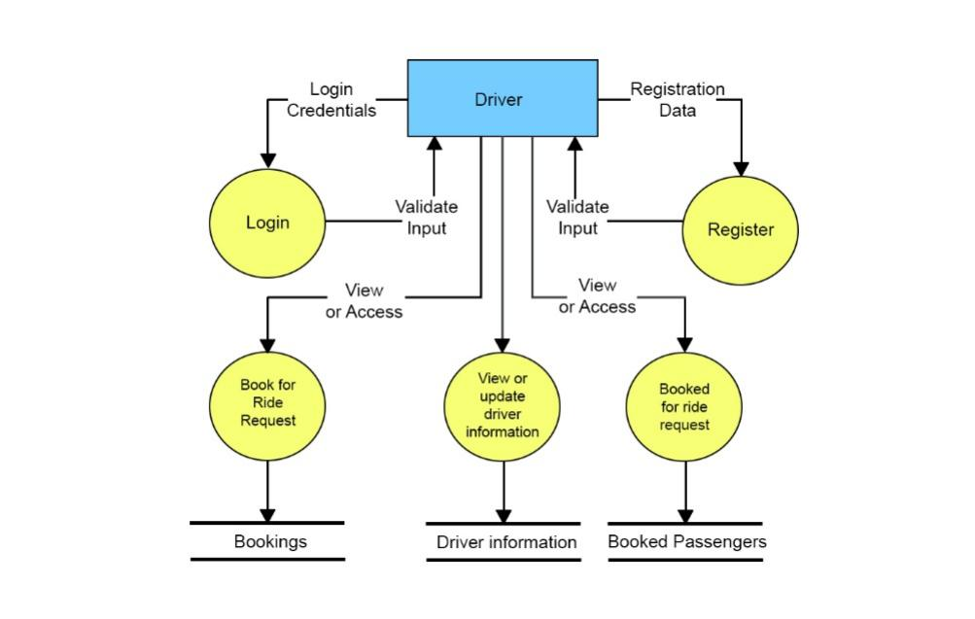

Figure 9. Data Flow Diagram for Drivers’ Side

*System Flow Chart*

The diagram below depicts the system's overall concept of how the system manages data and generates reports. The figure depicts the conditions that the system considers in each task and/or functionality for both the commuters’ side and driver’s side of the system.

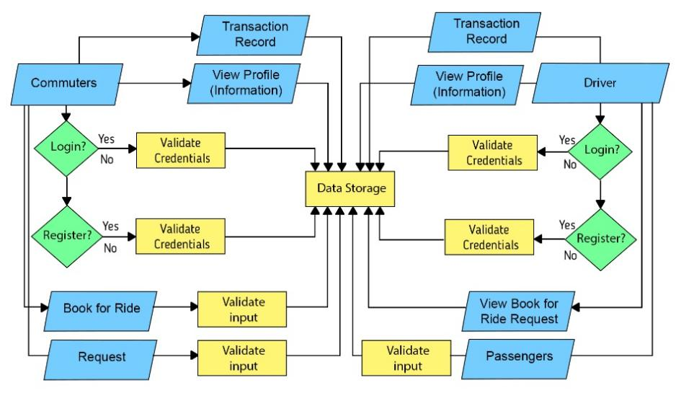

Figure 10. System Flow Chart

*Program Flow Chart*

The Program Flow Chart for both sides of the system are shown in the diagrams below. The figures depict the key aspects for both the commuters’ and drivers’ side of the project. This include and not limited to, inputs, and outputs, required reports.

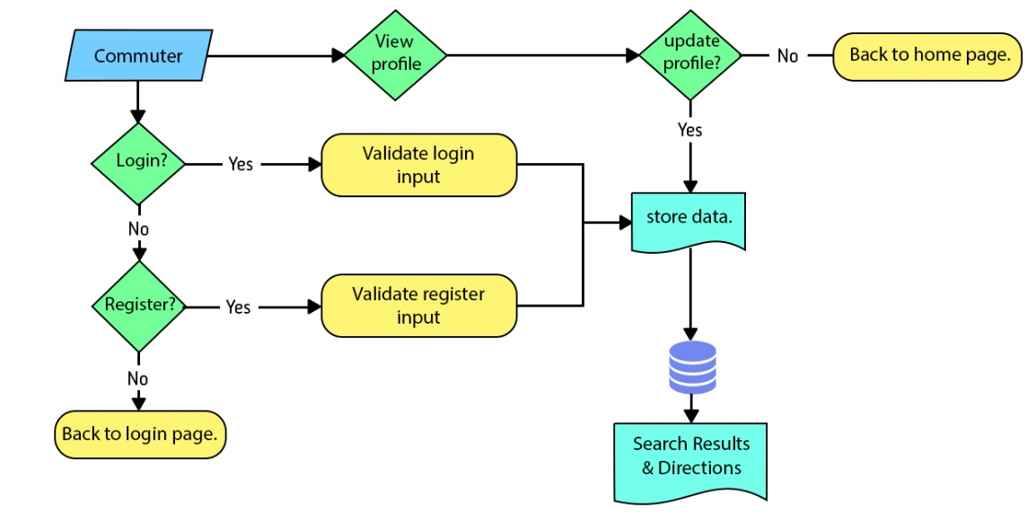

Figure 11. Program Flow Chart for Commuters’ Side

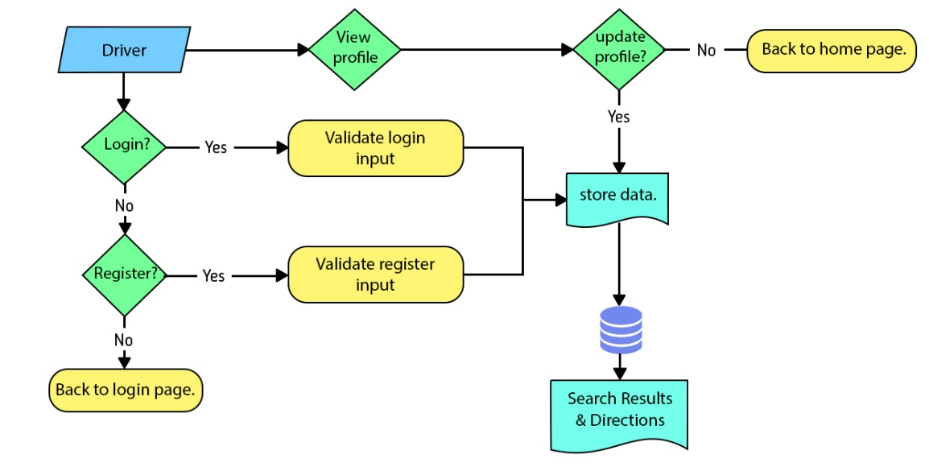

Figure 12. Program Flow Chart of the Drivers’ Side.

*Risk Assessment/Analysis*

The project's Risk Assessment/Analysis is shown in the table below. The table also depicts the risk analysis that the researchers aim to use to ensure that the project runs well. The table also lists any potential roadblocks that the system may face during project execution and deployment. The table below will be used to identify the preventive actions to ensures the projects effectiveness.

Table 3. Risk Assessment/Analysis

|  |  |  |  |  |
| --- | --- | --- | --- | --- |
| Threat | Vulnerability | Impact | Risk | Control Recommendation |
| System Failure  High | Sudden internet connection loss  High | All services will be unable  Critical | High  Data will not be stored | Choose a will trusted cloud service provider |
| Power interruption  Medium | Server firewall will be breached  Low | Data loss  Critical | Low  Data will not be stored | No actions. |
| Malicious Human Interference (DDOS Attack)  High | Cloud server provider has Good Firewall  Low | Process will be compromised  Critical | Low  Services and Data breached | No actions. |
| Accidental Human Interference – Data Deletion | Permissions and prompts are configured properly.  Medium | Services and functionalities will not be implemented properly. | Medium | Permissions and confirmations should be properly developed. |

**Design**

***Outputs and User-Interface Design***

*Forms*

The following images are used by the system to collect the necessary input from both sides of the project, the Commuters’ side, and the Drivers’ side. The forms also show what inputs are required for it to perform its function, as well as the planned inputs from both sides of the project to provide reports and outputs.

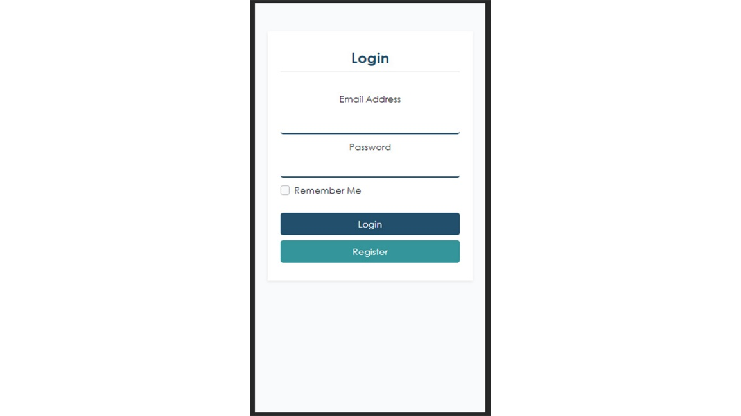

Form 1. Commuters Login Page

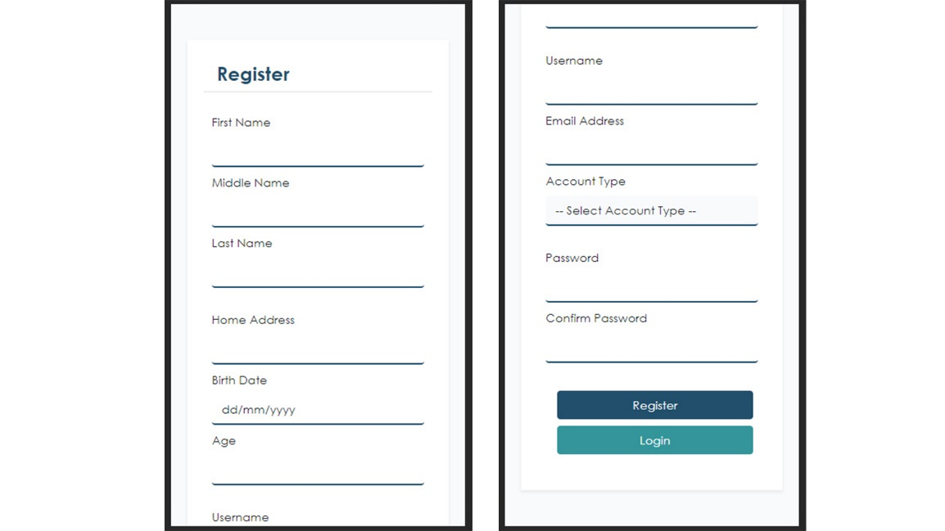

Form 2. Commuters Register Page

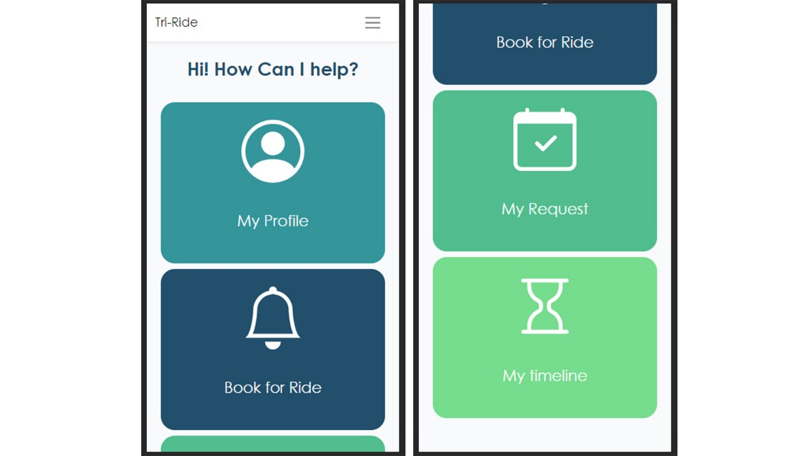

Form 3. Commuters Home Page

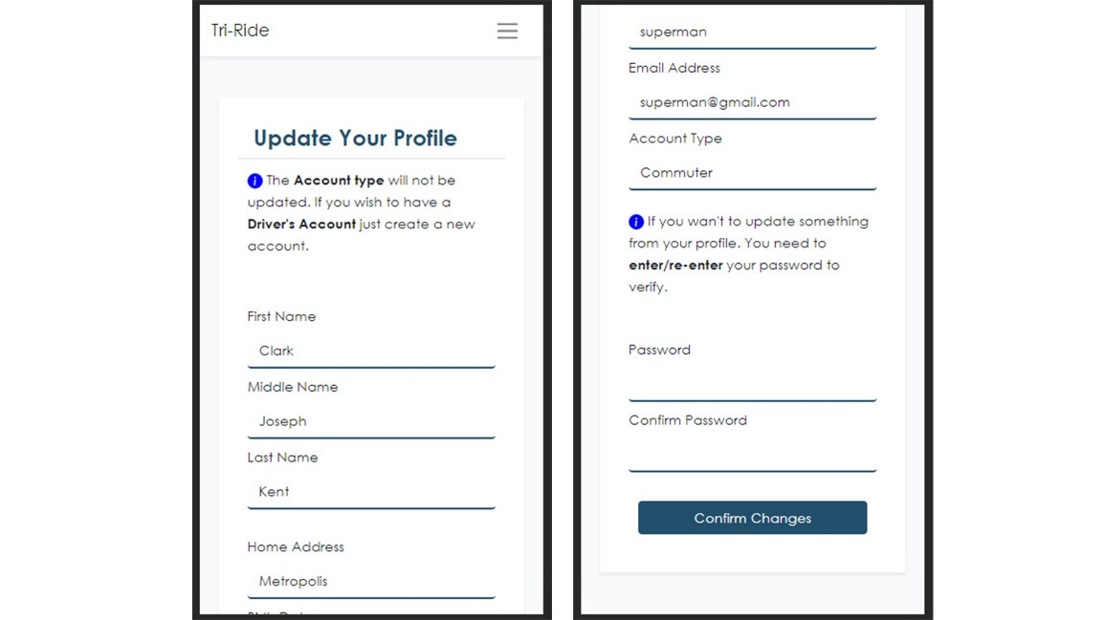

Form 4. Commuters My Profile Page

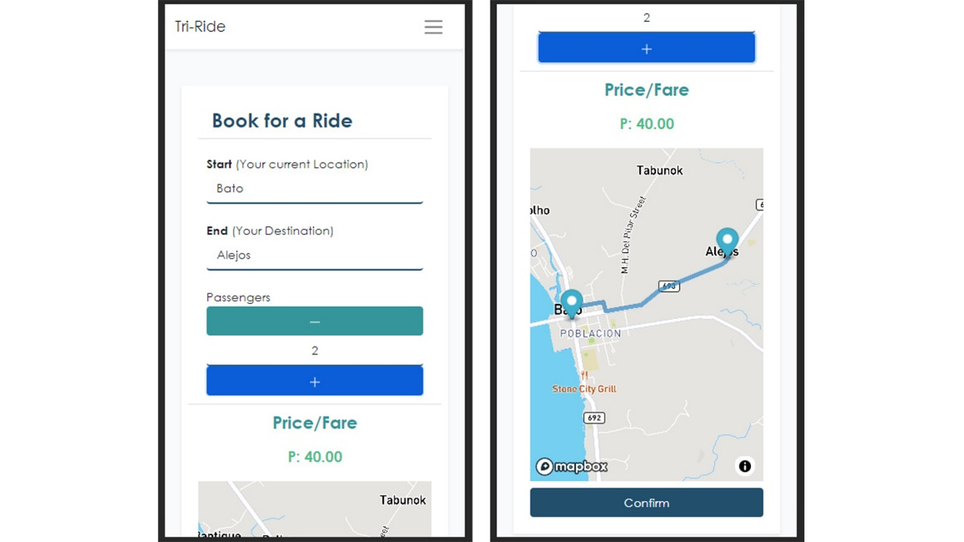

Form 5. Commuters Book for Ride Page

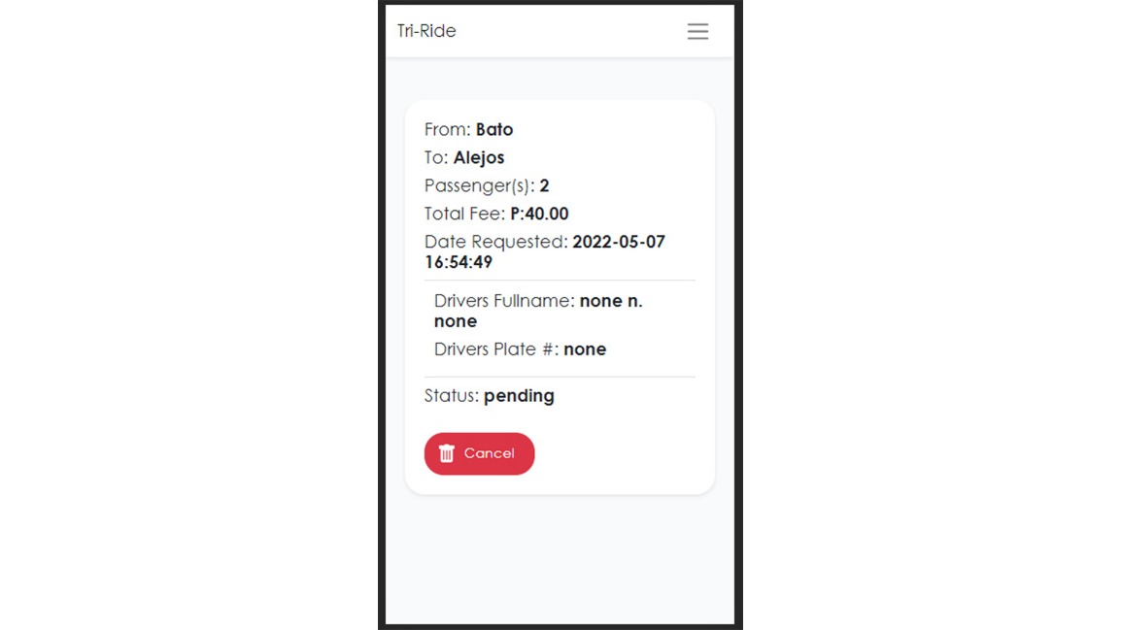

Form 6. Commuters Request Page

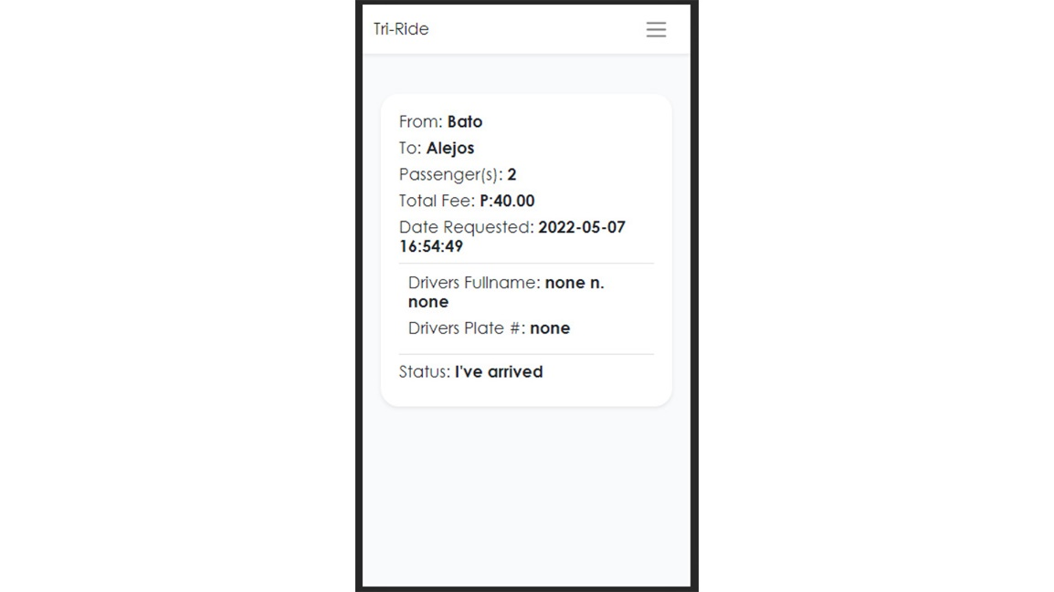

Form 7. Commuters Transaction Record Page



Form 8. Drivers Login Page



Form 9. Drivers Register Page

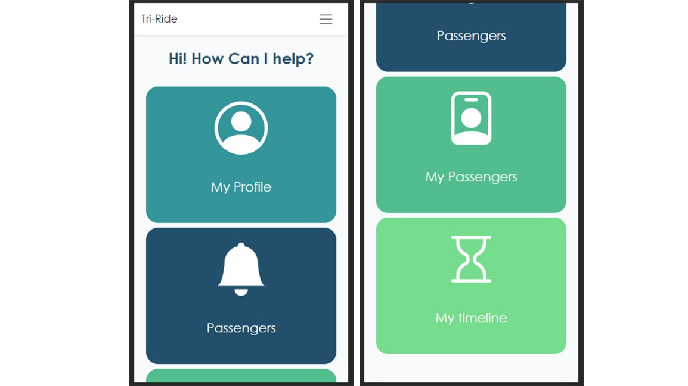

Form 10. Drivers Home Page

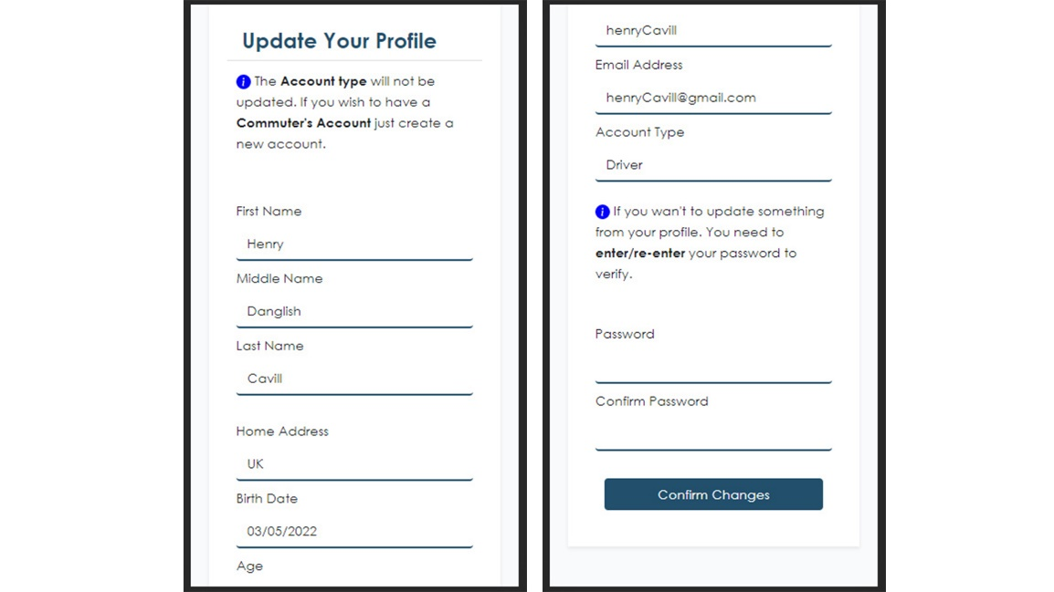

Form 11. Drivers’ My Profile Page

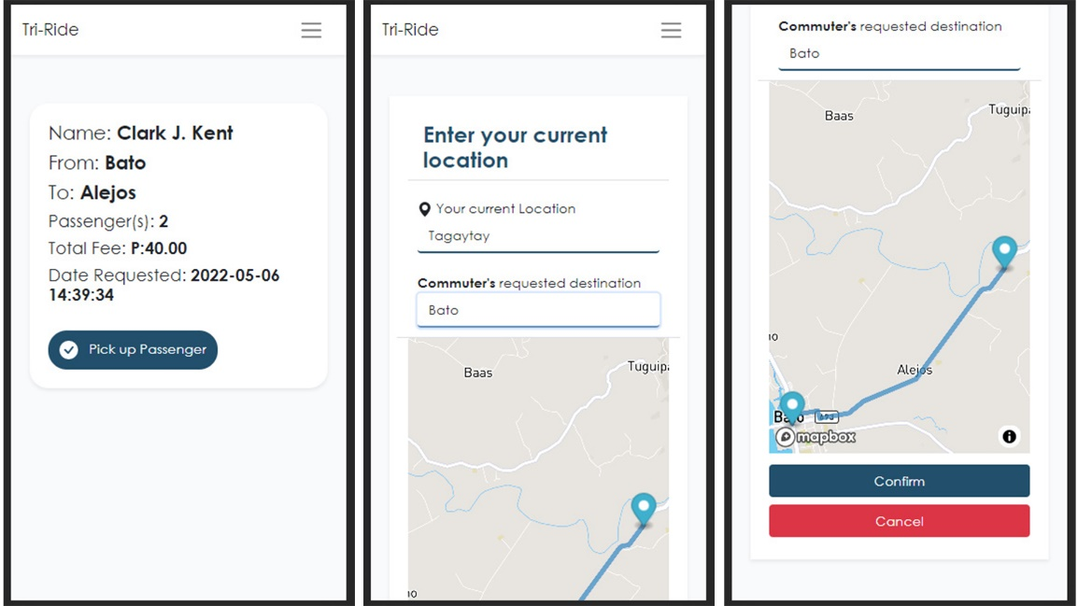

Form 12. Drivers’ Passengers Page

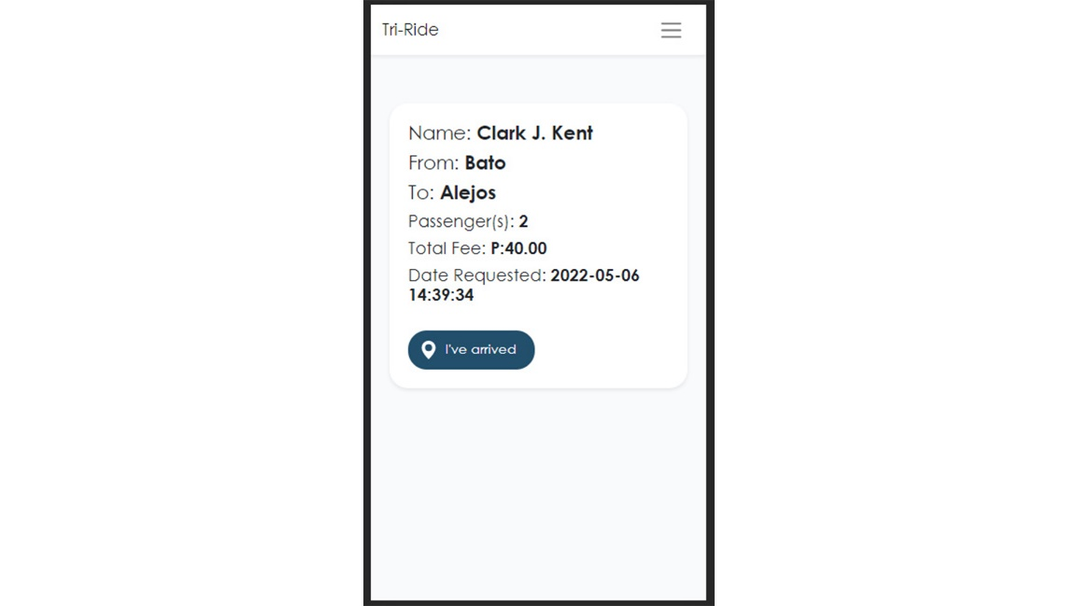

Form 13. Drivers My Passengers Page

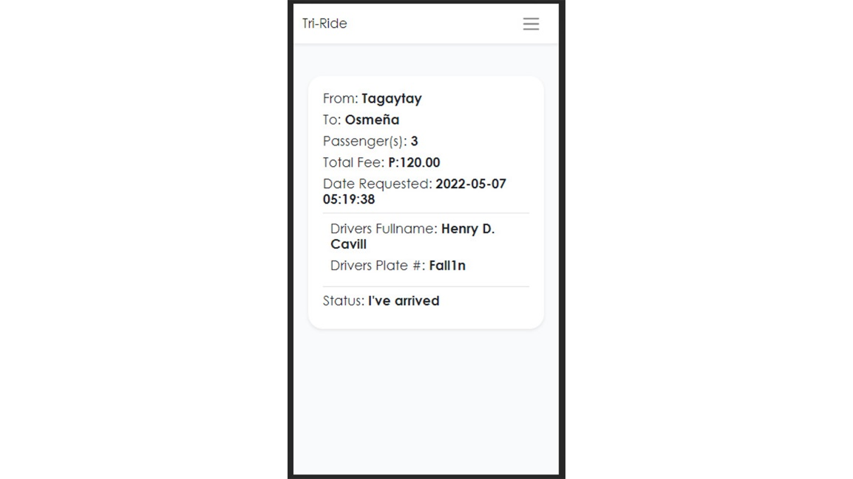

Form 14. Drivers Transaction Record Page

*Reports*

The reports that the system creates from the required inputs from the Commuters’ side of the project and the Drivers’ side of the project are shown below. These reports are a result of the system's ability to evaluate, interpret, and validate data from both sides of the project.

Report 1. Commuters Request Page

Report 2. Commuters Transaction Record Page

Report 3. Drivers Passenger Page

Report 4. Drivers My Passengers Page

Report 5. Drivers Transaction Record Page

***Data Design***

*Entity Relationship Diagram*

The Entity Relation Diagram for the system is shown below. The graphic depicts the entities that the system employed to generate acceptable outputs and complete tasks that were required to accomplish the project's goal. The entities reflect the many types of data that the system evaluates and analyzes to accomplish the project's goals.

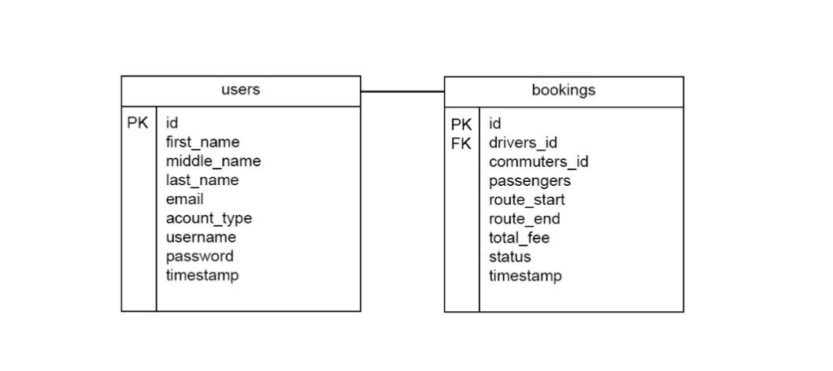

Figure 13. Entity Relationship Diagram

*Data Dictionary*

The data dictionary for the project is shown in the table below. It represents the type of information that the system processes, validates, stores, and prints. The data dictionary is based on the Entity Relationship Diagram presented in the previous section.

Table 4. Data Dictionary for Users Table

|  |  |  |  |  |
| --- | --- | --- | --- | --- |
| Field name | Data type | Field size | Description | Example |
| Id | Big int | 10 | Unique primary key for each user | 1 |
| First name | String | 255 | First name for each of the user. | Jonathan |
| Middle name | String | 255 | Middle name for each of the user | John |
| Last name | String | 255 | Last name for each of the user | Wick |
| Email | String | 255 | E-mail for each of the user | [johndoe@gmail.com](mailto:johndoe@gmail.com) |
| Account Type | String | 255 | Account for each of the user | Driver |
| Username | String | 255 | Username for each of the user | johnwick |
| Password | String | 255 | Hashed password of each of the user | $alijbakjwbdajwbakj.. |

Table 5. Data Dictionary for Bookings Table

|  |  |  |  |  |
| --- | --- | --- | --- | --- |
| Field name | Data type | Field size | Description | Example |
| Id | Big int | 10 | Unique primary key for each user | 1 |
| Drivers Id | Integer | 10 | Drivers id of the booking details | 1 |
| Commuters id | Integer | 10 | Commuters id of the booking details | 1 |
| Passengers | Integer | 10 | Number of Passenger for each booking detail | 2 |
| Route start | String | 255 | Starting location for each of the booking details | Anahawan |
| Route end | String | 255 | Destination for each of the booking details | Bato |
| Total fee | Double | 10 | Total Fee for each booked detail | 120.00 |
| Status | String | 255 | Status for each of the booked detail | On the way |

***System Architecture***

*Network Model*

The project network model is depicted in the graphic below. It demonstrates how each step and/or process is linked for both the commuters and driver sides of the project. This model was developed to depict the relationships between objects and processes on each project sides.

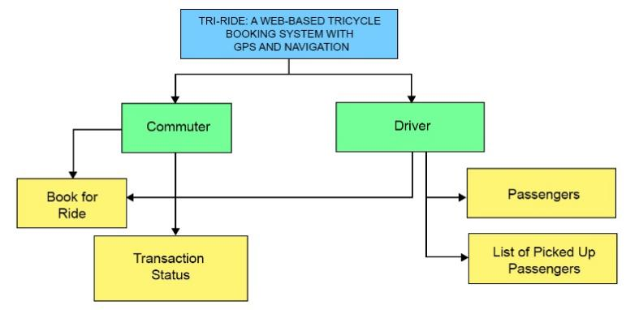

Figure 14. Network Model

*Network Topology*

The graphic below shows how both sides of the system's interactions take place through the internet. This also demonstrates how the contact or interaction between commuters and drivers takes place in general overview.

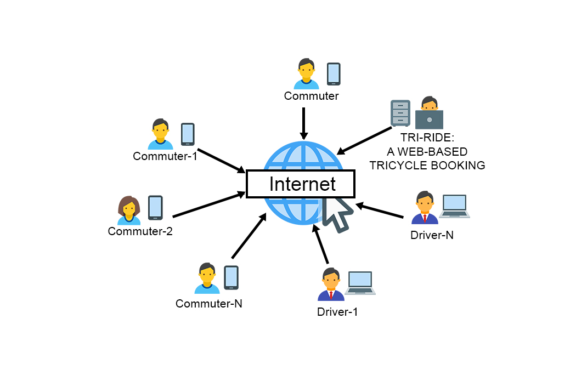

Figure 15. Network Topology

*Security*

The graphic below depicts how the proponents established the project's security implementation and protocol. The graphic depicts how and where security planning and implementation occur within the scope of the system's implementation.

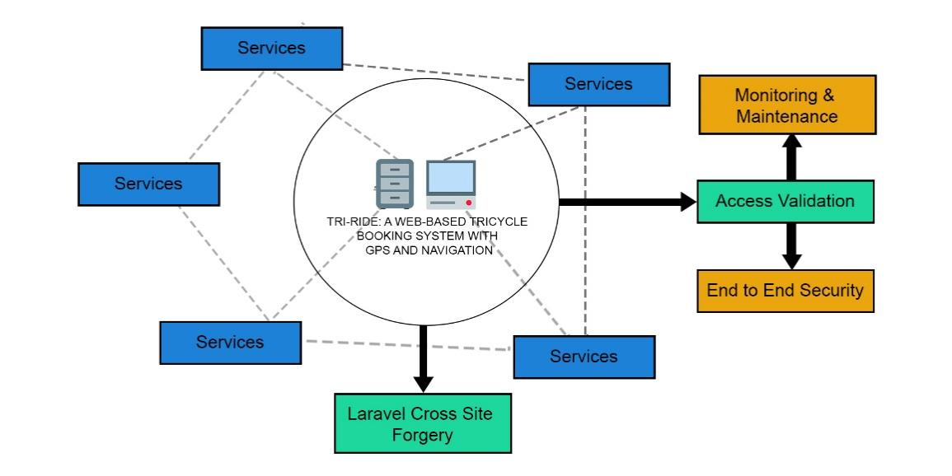

Figure 16. Security

**Development**

***Software Specification***

The following are the software requirements for the system to be fully functional and accessible to both drivers and commuters.

* Operating system
  + Windows 7-11
  + Latest android versions
* Brower
  + Google Chrome
  + Microsoft Edge
  + Opera Mini
  + Mozilla Firefox
* Brower Extension and tools
  + Adobe Flash Player

***Hardware Specification***

The following are the software requirements for the system to be fully functional and accessible to both drivers and commuters.

* 2GB Ram and Above
* At least Inter Core i3

***Program Specification***

The following are the required program specification for the system to be accessible and be fully functional for both the drivers and the Commuters.

* Programming Language Support
  + PHP
  + JavaScript

***Programming Environment***

**Table 6. Project Programming Environment**

|  |  |
| --- | --- |
| Front End | Back End |
| * Hyper Text Markup Language * Cascading Style Sheet * Bootstrap * jQuery * JavaScript | * **PHP language** * **Laravel Migrations** * **MySQL** * **AJAX** * **Leaflet** * **MapBox** |

***Deployment Diagram***

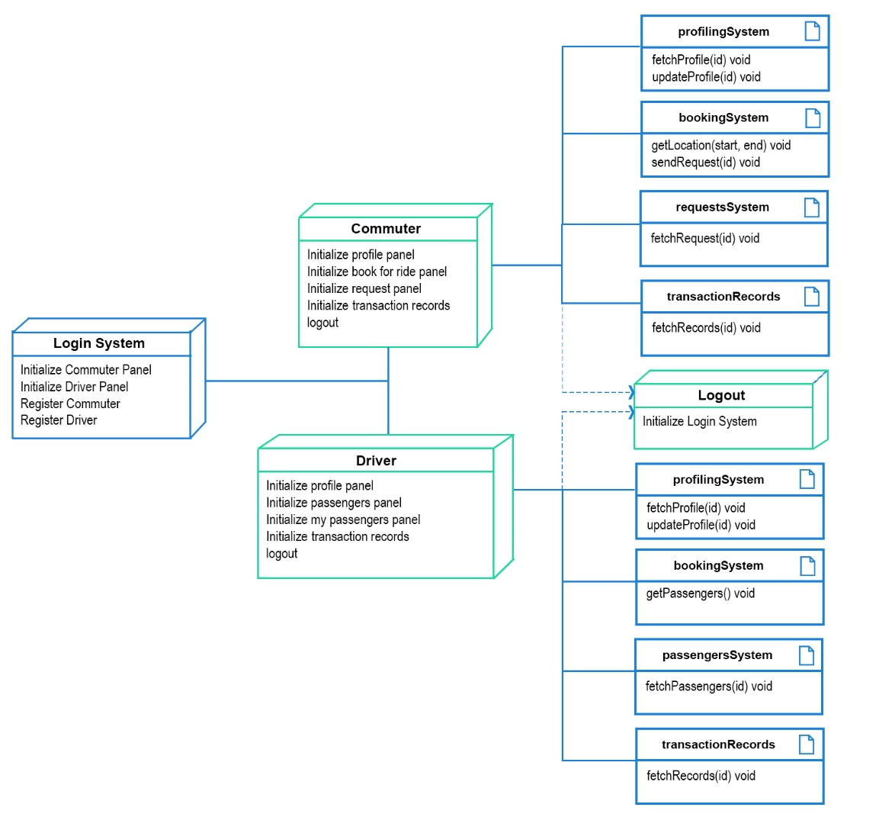

Figure 17. Deployment Diagram

***Test Plan***

Table 7. Project Test Plan

|  |  |  |  |
| --- | --- | --- | --- |
| Test Case | Description | Test Step | Expected result |
| Functionality | Each functionality, features, capability of the system. | Inputs, reports and request can be done simultaneously for both sides | Reports should be accurate. Function w/o errors. |
| Response Time | The amount of time for the system to generate reports and validate inputs. | Output and report generation is fast for both sides. | Response is fast and input validation is efficient. |
| Security | Ensure login credential checking. | Should be able to login according to login credentials. | Entered data are secured. |
| Usability | Each side is accessible. | Public users can search and trace location. Authorized personnel can do task seamlessly. | Every function can be done with no errors. |

**Testing**

***Unit Testing***

The unit testing for each module used in the project is listed in the tables below. Every module in the project represents a single form, and each module is tested according to its type, function, and desired outcome**.**

Table 8. Unit Testing Result 1

|  |  |  |  |
| --- | --- | --- | --- |
| Login Form | | | |
| Field | **Event** | Failed | Success |
| Email Address | Text changed | Error message – “Please fill form accordingly”. | Initialize login and validate input. |
| Password | Text changed | Error message – “Please fill form accordingly”. | Initialize login and validate input. |
| Remember me | Click event | No implemented action. | No implemented action. |
| Login button | Click event | Error message – “Please fill form accordingly”. | Initialize login and validate input. |
| Register button | Click event | No implemented action | Initialize register page. |

Table 9. Unit Testing Result 2

|  |  |  |  |
| --- | --- | --- | --- |
| Register Form | | | |
| Field | **Event** | Failed | Success |
| First name | Text changed | Error message – “Please fill form accordingly”. | Initialize register and validate input. |
| Middle name | Text changed | Error message – “Please fill form accordingly”. | Initialize register and validate input. |
| Last name | Text changed | Error message – “Please fill form accordingly”. | Initialize register and validate input. |
| Home Address | Text changed | Error message – “Please fill form accordingly”. | Initialize register and validate input. |
| Birth date | Date Select | Error message – “Please fill form accordingly”. | Initialize register and validate input. |
| Age | Text changed | Error message – “Please fill form accordingly”. | Initialize register and validate input. |
| Username | Text changed | Error message – “Please fill form accordingly”. | Initialize register and validate input. |
| Email address | Text changed | Error message – “Please fill form accordingly”. | Initialize register and validate input. |
| Account Type | Item Select | Error message – “Please fill form accordingly”. | Initialize register and validate input. |
| Password | Text changed | Error message – “Please fill form accordingly”. | Initialize register and validate input. |
| Confirm Password | Text change | Error message – “Password input doesn’t match”. | Initialize register and validate input. |
| Register button | Click event | No implemented action | Initialize register and validate input. |
| Login Button | Click event | No implemented action | Initialize login page. |

Table 10. Unit Testing Result 3

|  |  |  |  |
| --- | --- | --- | --- |
| My Profile Form | | | |
| Field | **Event** | Failed | Success |
| First name | Text changed | Error message – “Please fill form accordingly”. | Initialize register and validate input. |
| Middle name | Text changed | Error message – “Please fill form accordingly”. | Initialize register and validate input. |
| Last name | Text changed | Error message – “Please fill form accordingly”. | Initialize register and validate input. |
| Home Address | Text changed | Error message – “Please fill form accordingly”. | Initialize register and validate input. |
| Birth date | Date Select | Error message – “Please fill form accordingly”. | Initialize register and validate input. |
| Age | Text changed | Error message – “Please fill form accordingly”. | Initialize register and validate input. |
| Username | Text changed | Error message – “Please fill form accordingly”. | Initialize register and validate input. |
| Email address | Text changed | Error message – “Please fill form accordingly”. | Initialize register and validate input. |
| Account Type | Item Select | Error message – “Please fill form accordingly”. | Initialize register and validate input. |
| Password | Text changed | Error message – “Please fill form accordingly”. | Initialize register and validate input. |
| Confirm Changes | Button Click | Button click | Initialize update and validate input. |

Table 11. Unit Testing Result 4

|  |  |  |  |
| --- | --- | --- | --- |
| Book for Ride Form | | | |
| Field | **Event** | Failed | Success |
| Start (Current Location) | Item Select | Error message – “Please fill form accordingly”. | Initialize Map. |
| End (Destination) | Item Select | Error message – “Please fill form accordingly”. | Initialize Map and enable routing. |
| Remove Passenger Button | Button Click | No implemented Action. | Initialize passenger count. Update Passenger count input box. |
| Passenger Count | Text changed | Error message – “Please fill form accordingly”. | Initialize Passenger Count |
| Add Passenger Button | Button Click | No implemented Action. | Add Passenger Count. Update passenger count input box. |
| Map Box | Initialize Map | No Implemented Action. | Initialize Map enable Routing. |
| Confirm Button | Button Click | No Implemented Action. | Send Book for Ride Details. |

Table 12. Unit Testing Result 5

|  |  |  |  |
| --- | --- | --- | --- |
| Request Form | | | |
| Field | **Event** | Failed | Success |
| From | Not implemented Action. | Not implemented Action. | Display requested starting location. |
| To | Not implemented Action. | Not implemented Action. | Display requested destination. |
| Passenger(s) | Not implemented Action. | Not implemented Action. | Display requested # of passengers. |
| Date Requested | Not implemented Action. | Not implemented Action. | Display date requested. |
| Driver Full name | Not implemented Action. | Not implemented Action. | Display drivers full name. |
| Driver’s plate # | Not implemented Action. | Not implemented Action. | Display driver’s plate #. |
| Status | Not implemented Action. | Not implemented Action. | Display request status |
| Cancel button | Button click | Not implemented Action. | Cancel request. |

Table 13. Unit Testing Result 6

|  |  |  |  |
| --- | --- | --- | --- |
| Timeline Form | | | |
| Field | **Event** | Failed | Success |
| From | Not implemented Action. | Not implemented Action. | Display requested starting location. |
| To | Not implemented Action. | Not implemented Action. | Display requested destination. |
| Passenger(s) | Not implemented Action. | Not implemented Action. | Display requested # of passengers. |
| Date Requested | Not implemented Action. | Not implemented Action. | Display date requested. |
| Driver Full name | Not implemented Action. | Not implemented Action. | Display drivers full name. |
| Driver’s plate # | Not implemented Action. | Not implemented Action. | Display driver’s plate #. |
| Status | Not implemented Action. | Not implemented Action. | Display request status |

***Integration Testing***

*Compatibility Testing*

Because of its nature, the project was tested on the following internet browsers to see if its functionalities, modules, and purpose are as intended. The proponents utilized the devices in the developers’ option of each internet browsers to determine the project effectiveness.

1. Google Chrome
2. Microsoft Edge
3. Mozilla Firefox
4. Opera Mini

*Performance Testing*

The project testing phase then moved on to testing the system's performance. The project's web-based nature demonstrates that the system's performance is totally dependent on its internet access. Furthermore, the APIs that the system uses are heavily reliant on internet access. The internet connection must be monitored regardless of which browser is used to access the system. With this exception, the project proved to be efficient and effective.

*Stress Testing*

To test the system's ability to work beyond its intended use. As a result, the system's ability to handle stress from many data requests and validation was put to the test while using the above-mentioned internet browsers at the same time.

*Load Testing*

The system's ability to handle large amounts of data was tested by storing large amounts of commuters’ data and registering accounts from the project's drivers’ side. It was discovered that when the amount of data saved in the project's database reaches a particular threshold, data retrieval from the both sides of the project takes longer response time..

***System Testing***

This research stated that the system has gone through routine testing steps. The system was put through a total of six testing phases, each of which assessed the system's ability to work and run when various operational obstacles were encountered. Regardless, the system performed well in all the main areas that were examined throughout development.

**Conclusion**

Based on the findings and data gathered from testing the system on various operational hindrances, the proponent of the study concludes that:

1. The system is effective in providing tricycle online booking platform.
2. The system is effective in allowing tricycle drivers to pre-determine the number of commuters based on tricycle service requests.

**Recommendation**

The system is effective and is advantageous in providing a pre-tricycle booking platform for both commuters and drives of Bato, Leyte. However, the system in its entirety is limited. Therefore, the proponents recommend the following:

1. The system must have rate service feature to provide interactivity.
2. Real-time user location feature, to automate a user’s starting location information.
3. Must have data analysis based on commuters and drives interaction within the system.

**Implementation Planning**

***Project Implementation Checklist***

The proponents analyzed facts that would pave more ways to make the project execution as effective and accurate as possible during the implementation phase. The table below contains a list of items to consider completing the project and make it as efficient as feasible.

Table 14. Project Implementation Plan

|  |  |  |
| --- | --- | --- |
| # | Task | Status |
| 1. | Project Implementation Meeting |  |
| 2. | System presentation Planning |  |
| 3. | Deployment Procedure |  |
| 4. | System Testing |  |
| 5. | System Validity Checking |  |
| 6. | Project Finalization |  |

***Implementation Contingency***

The table below contains a list of issues to deal as during project implementation phase, as well as potential errors and contingencies. The table indicates what contingencies the proponents used in the event of a project implementation setback.

Table 15. Implementation Contingency

|  |  |  |
| --- | --- | --- |
| # | Task | Contingency |
| 1 | Project Implementation Meeting | During this meeting, possible hindrance be determined should prior to actual implementation. |
| 2 | System Presentation Planning | Possible scenario that would result to errors should be planned beforehand. |
| 3 | Deployment Procedure | Refactoring of routes and API connection should be checked before and after a while. |
| 4. | System Testing | After the deployment procedure. Double check the systems functionalities. |
| 5. | System Validity Checking | Check system’s runtime process. |
| 6. | Project Finalization | Finalize everything. |

***Infrastructure/Deployment***

The system's infrastructure is depicted in the diagram below. It is the reflection of the system's interaction from source code modules to request routes, which occurs or is accessed from both sides of the system. It depicts the broad aspects affecting its deployment or infrastructure.

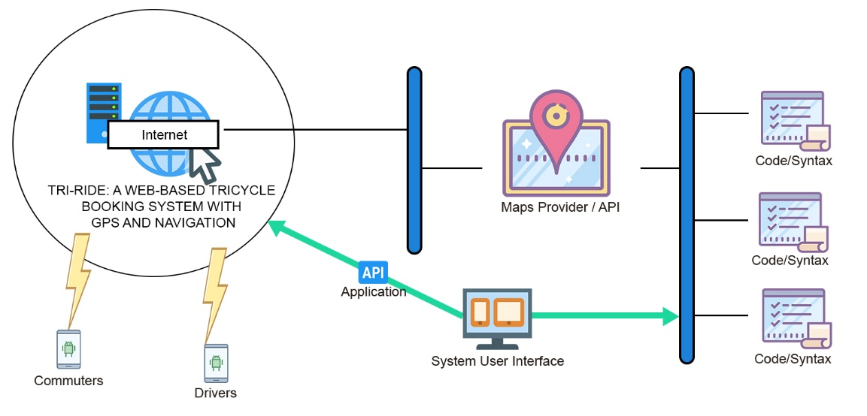

Figure 18. Infrastructure or Deployment.

**BIBLIOGRAPHY**

[1] “What is Data Dictionary”,tutorialspoint

[2] “What is System Network Architecture”,ibm

[3] 2001, “Network Models”,informit

[4] “What is Network Topology”,omnisci

[5] “What is Security Architecture? ”,techslang

[6] 2020 ,“Tips to Write a Technical…”,wishdesk

[7] AndrewBurak,“How to Write Software Requirements…”,relevant.software

[8] “Program Specification”,oxfordreference

[9] “Deployment Diagram for a typical Web-based application”, researchgate

[10] “What is unit Testing?..”software quality.techtargt

[11] 2020,“Integration Testing”,u-tor

[12] Satyabrata_Jena,2021,“Compatibility Testing in Software Engineering”geeksforgeeks

[13] “What is Integration Testing (Tutorial with Integration Testing Example)”,google

[14] Thomas Hamilton,2021,”TEST PLAN:What is,How to Create(with Example)”,gu

[15] “Identity Management Infrastracture Deployment Planning”,docs.oracle

[16] Thembani Thembani,“Requirements+ Modeling”,studylib

[17] Alexander S. Gillis,“What is Performance Testing?”,hsoftwarequality.techtarget

[18] Austin Miller,2021,“Performance Testing, Load Testing & Stress Testing Explained”,bmc

[19] Thomas Hamilton,2021,“Performace Testing Tutorial:What is, Types,Metrics & Example”,guru99

[27] Thomas Hamilton,2021,“What is System Testing? Types & Definition with Example”,guru99

[20] “System Testing”,javapoint

[21] Adam Hayes,2020,“Acceptance Testing”,Investopedia

[22] “User Acceptance Testing…”,performancelabus

[23] 2019,“What is Acceptance Testing? Types and Example-W3Softech”,w3softech

[24] 2020,“Acceptance Testing in Software Engineering”,prepinsta

[25] Team Asana,2021,“What is an Implementation plan?6 steps to create one”,asana

[26] “Implemantation Checklist”,learn.nes.nhs.scot

[27] “Project Implemantation Checklist”,google

[28] Clive Longbottom, Stephen J. Bigelow,“What is Infrastructure…”,earchdatacenter.techtarget

[29] “Deployment Infrastructure”,ibm

**APPENDICES**

**APPENDIX A**

**Relevant Source Code**

Mapbox and Leaflet Scripts

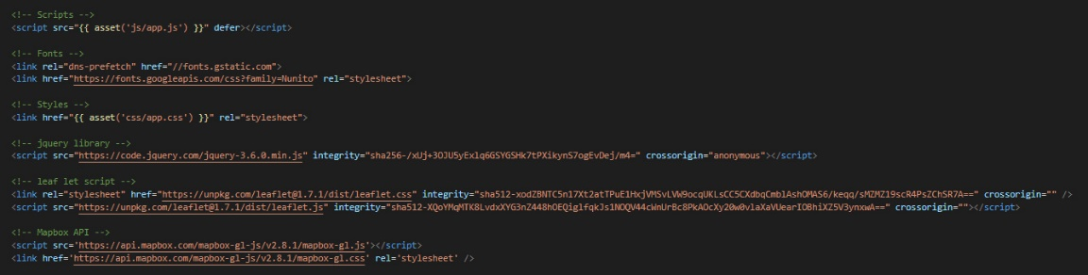

Mapbox and Leaflet API Key

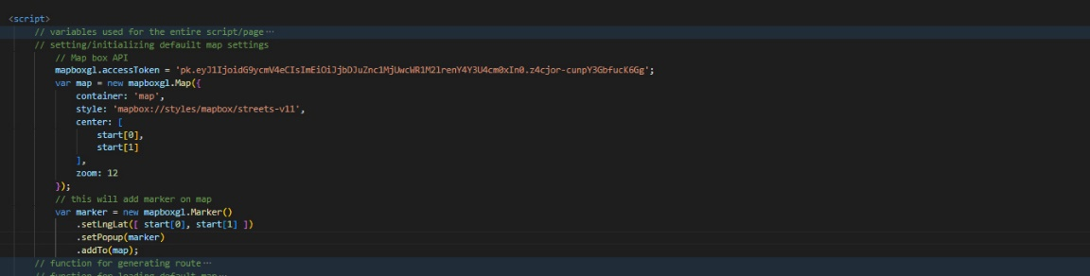

Request Routes

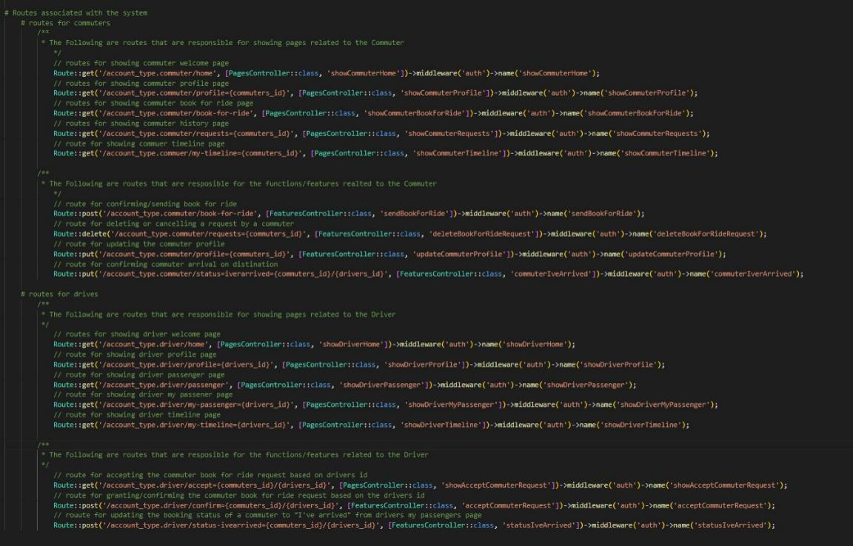

**APPENDIX B**

**Evaluation Tool**

**System Evaluation (ISO 9126)**

**Instructions:** Please evaluate the “Tri-Ride: A Web-based Tricycle Booking System with GPS and Navigation” using the scale shown below. Check (/) the appropriate score. Thank you.

**Jughead Team** Kenno Nikko L. Sy

Programmer Adviser

**Qualitative Description per Functionality Indicator**

|  |  |
| --- | --- |
| **Limits of Scale** | **Qualitative Description** |
| 4.21 – 5.00 | Fully Functional |
| 3.21 – 4.20 | Mostly Functional |
| 2.61 – 3.20 | Functional |
| 1.81 – 2.60 | Slightly Functional |
| 1.0 – 1.8 | Not Functional |

**Qualitative Description per Usability Indicator**

|  |  |
| --- | --- |
| **Limits of Scale** | **Qualitative Description** |
| 4.21 – 5.00 | Fully Usable |
| 3.21 – 4.20 | Mostly Usable |
| 2.61 – 3.20 | Usable |
| 1.81 – 2.60 | Slightly Usable |
| 1.0 – 1.8 | Not Usable |

|  |  |  |  |  |  |  |
| --- | --- | --- | --- | --- | --- | --- |
| **Criteria** | | **Score** | | | | |
| *Characteristics* | *Sub Characteristics* | **1** | **2** | **3** | **4** | **5** |
| Functionality | The application performs the required functionalities |  |  |  |  |  |
| The application provides the expected result |  |  |  |  |  |
| Usability | The graphical user interface of the application is easy to use or navigate |  |  |  |  |  |
| The displayed results of the system are understandable |  |  |  |  |  |

**APPENDIX C**

**Sample Input and Output**

Sample Input



Sample Output



**APPENDIX D**

**User’s Guide**

Login page

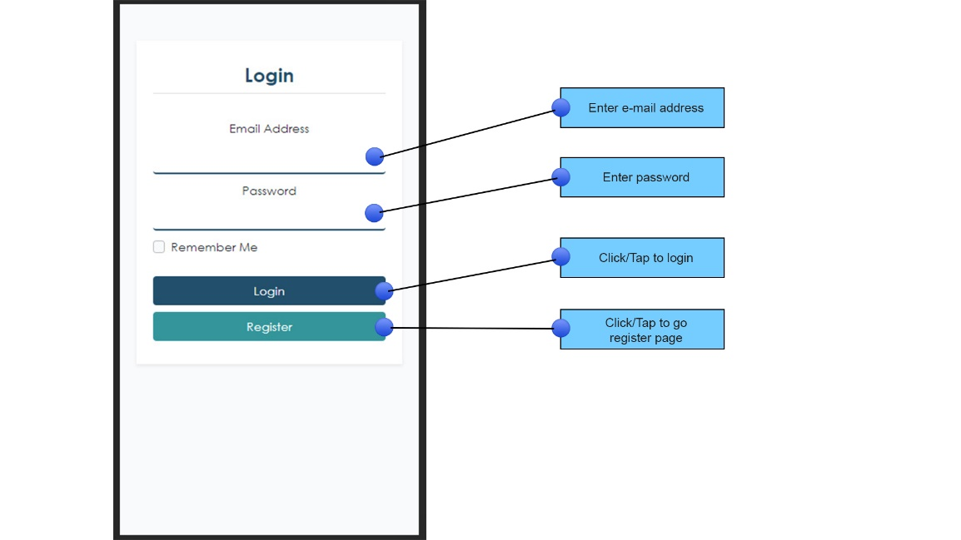

Register Page

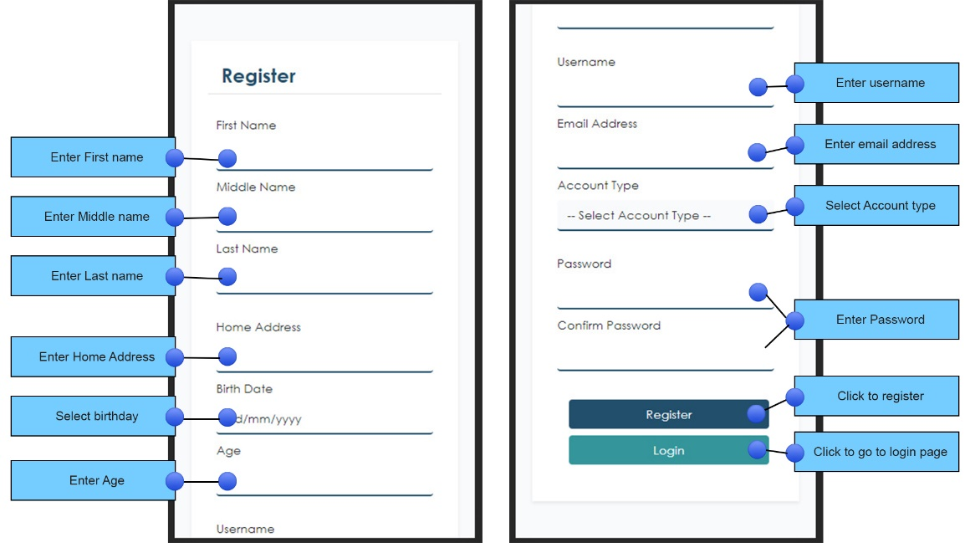

Home Page

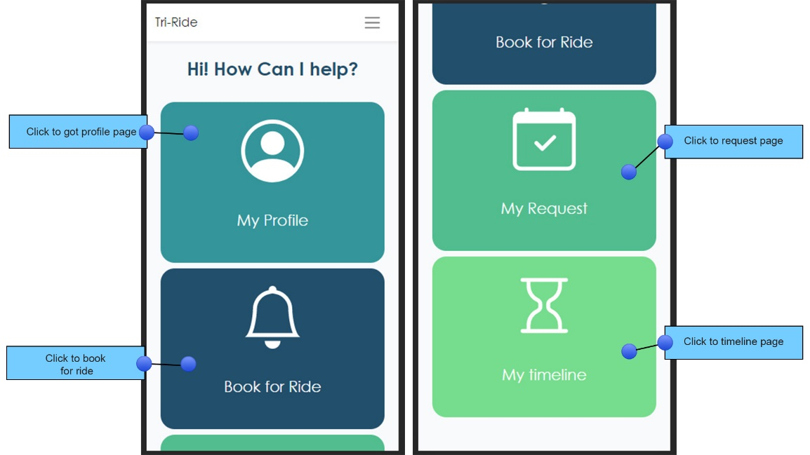

Profile Page

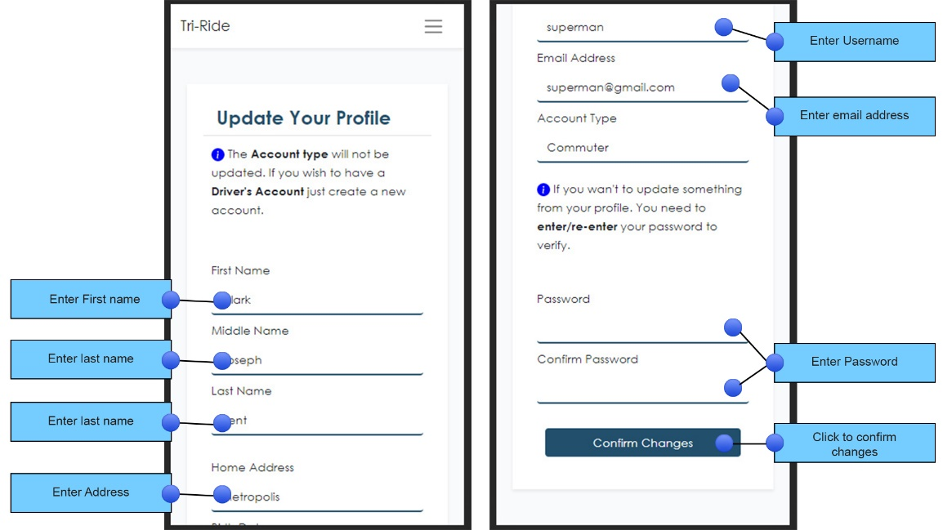

Book for Ride Page

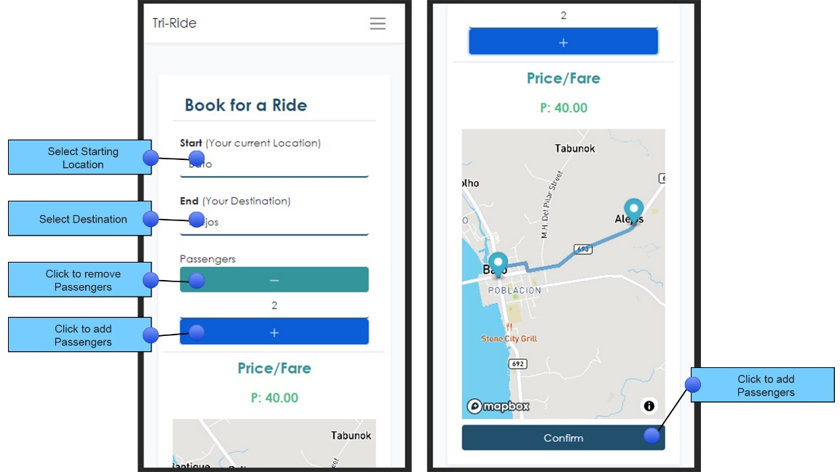

Request Page

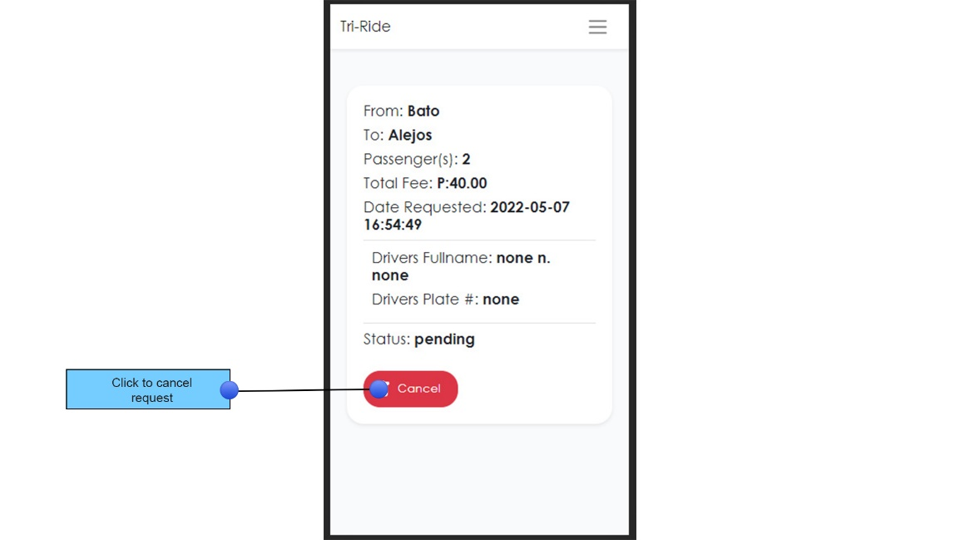

**APPENDIX E**

**Other Relevant Documents**

Env File

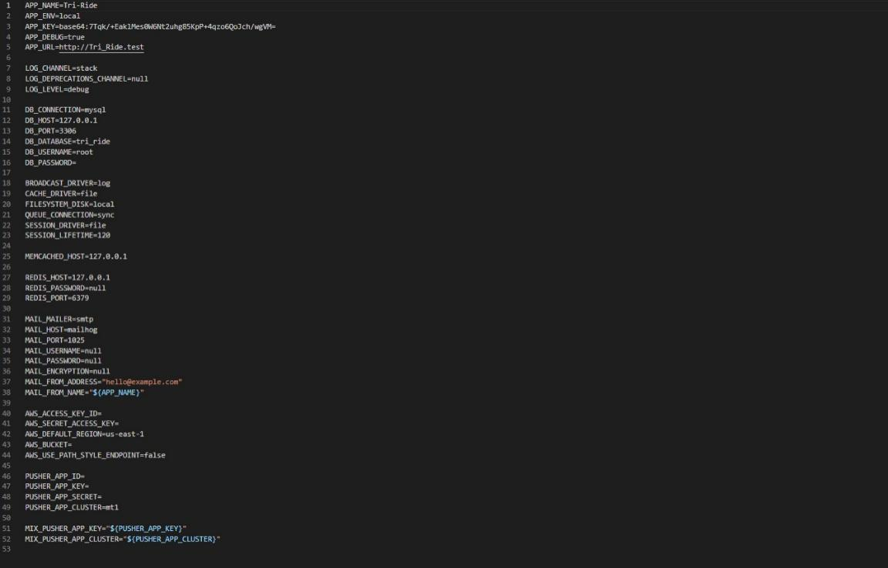

Features Controller

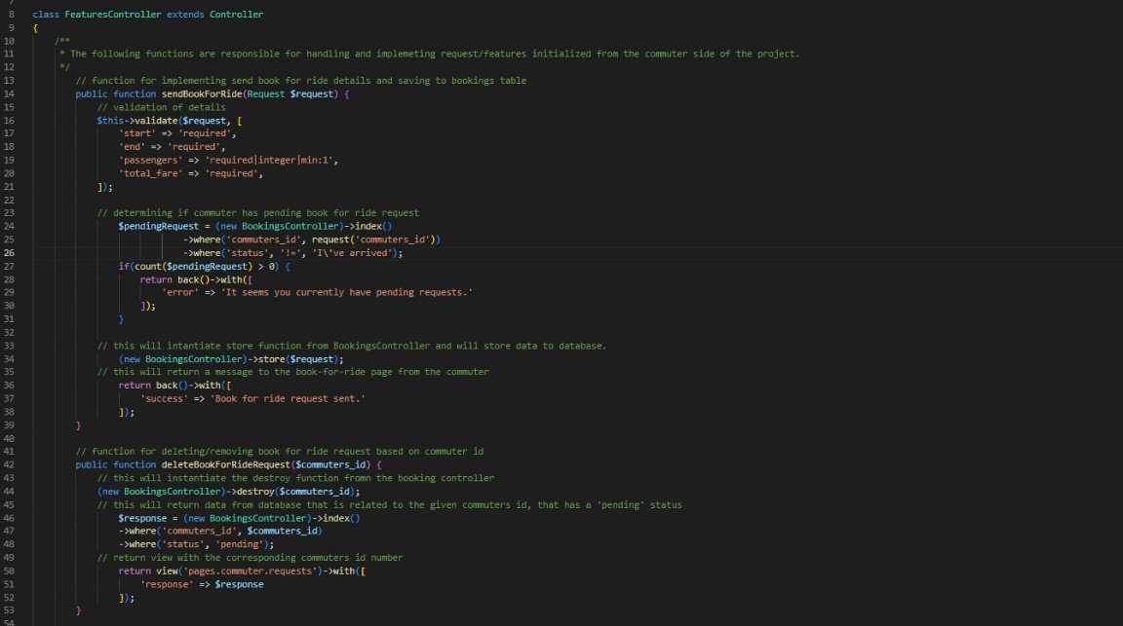

**APPENDIX F**

**Working Title Form**

Republic of the Philippines

**SOUTHERN LEYTE STATE UNIVERSITY**

Sogod, Southern Leyte

Website: [www.slsuonline.edu.ph](http://www.slsuonline.edu.ph)

Email: [slsumaincampus@gmail.com](mailto:slsumaincampus@gmail.com)

op@slsuonline.edu.ph Telefax No. (053) 382-3294

***College of Computer Studies and Information Technology***

**Proponents/Researchers:**

|  |
| --- |
| Irene B. Arnaiz |
| Cesar D. Brillo |
| Jenny M. Fortaliza |
| Medilyn C. Garzon |

**Proposed Project Title:**

|  |
| --- |
| **Tri-Ride: A Web-based Tricycle Booking System with GPS and Navigation** |

|  |  |
| --- | --- |
| **Submitted by:**  **Cesar D. Brillo**  (Signature of Project Manager over printed name)  Date: May 11, 2022 | **Noted:**  **Keanno Nikko L. Sy,** SGD  (Signature of Adviser over printed name)  Date: |
| **Recommending Approval:**  (Signature of Patent Searcher over printed name)  Date: | **Approved:**  **Alex C. Bacalla, DIT**  (Signature of Dean over printed name)  Date: |

**APPENDIX G**

**Grammarians’ Certification**

Republic of the Philippines

**SOUTHERN LEYTE STATE UNIVERSITY**

Sogod, Southern Leyte

Website: [www.slsuonline.edu.ph](http://www.slsuonline.edu.ph)

Email: [slsumaincampus@gmail.com](mailto:slsumaincampus@gmail.com), [op@slsuonline.edu.ph](mailto:op@slsuonline.edu.ph)

Telefax No. (053) 382-3294

***College of Computer Studies and Information Technology***

Date: _____________

**G R A M M A R I A N ‘ S C E R T I F I C A T E**

This is to certify that the undersigned has reviewed and went through all the pages of the proposal project study / research entitled “Tri-Ride: A Web-based Tricycle Booking System with GPS and Navigation” as against the set of structural rules that governs the composition of sentences, phrases, and words in the English language.

Signed:

_________________________

Grammarian

Conformed:

**Cesar D. Brillo**

Project Manager

**APPENDIX H**

**Curriculum Vitae**

**Full name: Cesar D. Brillo**

Address: Brgy. Zome 1 Sogod, So. Leyte

Mobile Number: +639061880537

Email Address: cesarbrillo8@gmail.com

**PERSONAL INFORMATION**

Nickname : Cesar

Date of Birth : 10-28-1998

Place of Birth : Quezon City

Civil Status : Single

Citizenship : Filipino

Age : 23

Gender : Male

Religion : R.C.

Father's Name : Francis Brillo

Mother's Name : Divina Dayola

**EDUCATIONAL ATTAINMENT**

Tertiary Education : Southern Leyte State University – Main Campus

Year : 2018-2022

Course : Bachelor in Science and Information Technology

Major : Programming

Address : San Roque, Sogod, So. Leyte

Secondary Education : Waterloo National High School

Year : 2015

Strand : N/A

Specialization : N/A

Address : Brgy. Tigbao, Matalom Leyte

**Curriculum Vitae**

**Full name: Irene B. Arnaiz**

Address: Brgy. Zome 1 Sogod, So. Leyte

Mobile Number: +639168619139

Email Address: arnaizirene167@gmail.com

**PERSONAL INFORMATION**

Nickname : Yang

Date of Birth : 01-09-1991

Place of Birth : Sogod So. Leyte

Civil Status : Single

Citizenship : Filipino

Age : 31

Gender : Female

Religion : R.C.

Father's Name : Elmer S. Arnaiz

Mother's Name : Donata B. Arnaiz

**EDUCATIONAL ATTAINMENT**

Tertiary Education : Southern Leyte State University – Main Campus

Year : 2018-2022

Course : Bachelor in Science and Information Technology

Major : Programming

Address : San Roque, Sogod, So. Leyte

Alternative Learning System

Year Graduated: 2011

Secondary Education : Sogod National High School

Year : 2008

Strand : N/A

Specialization : N/A

Address : Brgy. Zone 1 Sogod, So. Leyte

**Curriculum Vitae**

**Full name: Medilyn C. Garzon**

Address: Brgy. Tabunok Bato, Leyte

Mobile Number: +639654125932

Email Address: medilyngarzon99@gmail.com

**PERSONAL INFORMATION**

Nickname : Shawn

Date of Birth : August 20, 1999

Place of Birth : Tabunok Bato, Leyte

Civil Status : Single

Citizenship : Filipino

Age : 22

Gender : Female

Religion : Roman Catholic

Father's Name : Danilo Garzon

Mother's Name : Melona Garzon

**EDUCATIONAL ATTAINMENT**

Tertiary Education : Southern Leyte State University – Main Campus

Year : 2018-Present

Course : Bachelor in Science and Information Technology

Major : Programming

Address : San Roque, Sogod, So. Leyte

Secondary Education : Bato National High School

Year : 2018

Strand : TVL

Specialization : SMAW

Address : Bagong Bayan Bato, Leyte

**Curriculum Vitae**

**Full name: Jenny M. Fortaliza**

Address: Sitio. Albanga, Anahawan, Bato, Leyte

Mobile Number: +639656245901

Email Address: fortalizajenny033@gmail.com

**PERSONAL INFORMATION**

Nickname : Jenn

Date of Birth : June 18, 1994

Place of Birth : Pasig City

Civil Status : Single

Citizenship : Filipino

Age : 27

Gender : Female

Religion : Born Again Christian

Father's Name : Danilo P. Fortaliza

Mother's Name : Dygen M. Maboloc

**EDUCATIONAL ATTAINMENT**

Tertiary Education : Southern Leyte State University – Main Campus

Year : 2018-Present

Course : Bachelor in Science and Information Technology

Major : Programming

Address : San Roque, Sogod, So. Leyte

Secondary Education : Anahawan National High School

Year : 2011-2012

Strand : N/A

Specialization : N/A

Address : Brgy. Anahawan, Bato, Leyte